Biological Artifacts in EEG - Lab Report

ECBM 4090 - Brain Computer Interface Lab

09/19/2024

Ian Huang, Lindsey Ma, Giuliana Cascarano

[Nima Mesgarani](mailto:nima@ee.columbia.edu)

**Introduction**

Brief overview of EEG and the significance of identifying artifacts.

Objectives of the lab: To practice recording EEG data under various conditions and identify different kinds of artifacts.

**Experiment 1: EEG Signal Visualization and Data Storage**

Visualization and Initial Analysis

* In this experiment we measured the EEG activity of Fz, FC1, FC2, and Pz during a variety of conditions: while the subject is sitting silently, blinking, rolling eyes, chewing, tensing the neck, and touching the electrodes.

1. Inspect the EEG data from the four channels (Fz, FC1, FC2, & Pz) under different behavioral conditions. What does the EEG data look like under each condition?
   1. Under the ‘sitting quietly’ condition we saw a clear alpha wave in the signal.
   2. For eye blinking, in general we saw a big signal spike whenever there was a blink. However, this blink was less seen in Pz possibly due to it being the farthest from the eye.
   3. For eye rolling, we also saw big spike waves whenever the eyeball was rolled. For chewing, we saw bursts of spikes when the subject was chewing.
   4. For neck tensing, we also saw high frequency waves when the subject was tensing.
   5. When the subject was touching the electrodes, the electrode that was touched also experienced high amplitude and frequency of waves.
2. Determine when you are recording clean EEG data. What are the visual indicators of clean data?
   1. We can see a stable and smooth baseline representing the real brain rhythm without many abrupt changes.

Data Analysis

1. Screenshot each condition, and adjust the number of seconds on the display so you can see the type of artifacts, and
   1. Include x- and y- scaling in the printout.
2. Measure and report the amplitude of each artifact for all four channels.
   1. Eye Blinks

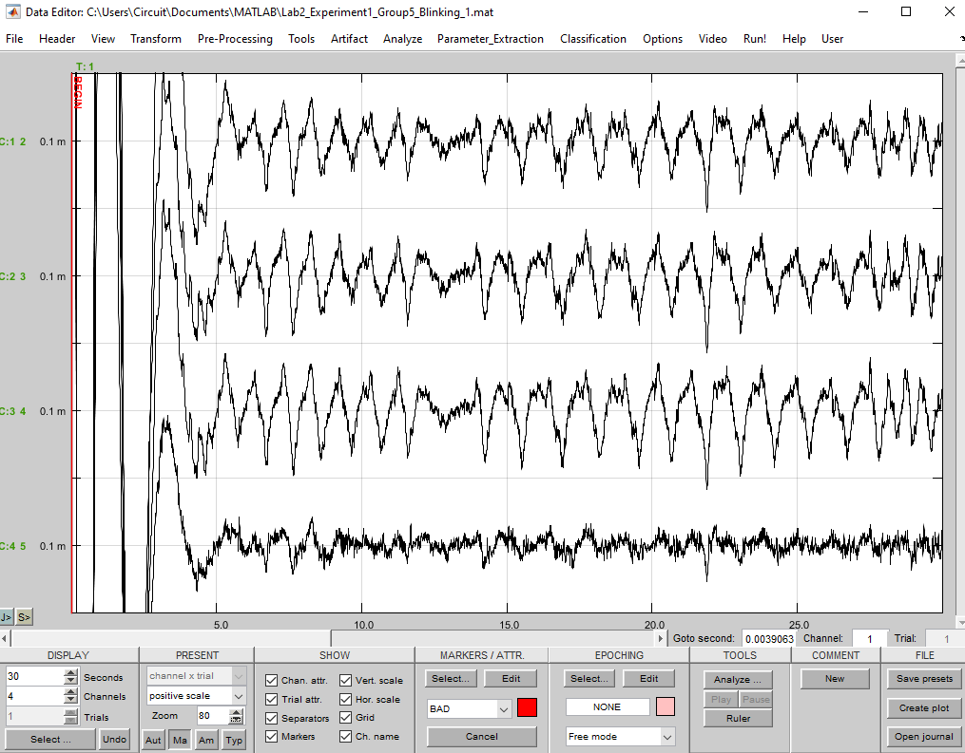

The first three channels show similar waveforms, characterized by spikes and regular frequency. The Pz channel, while appearing more intense, carries less information in terms of frequency and pattern, and has a lower amplitude.

* 1. Eye Rolling

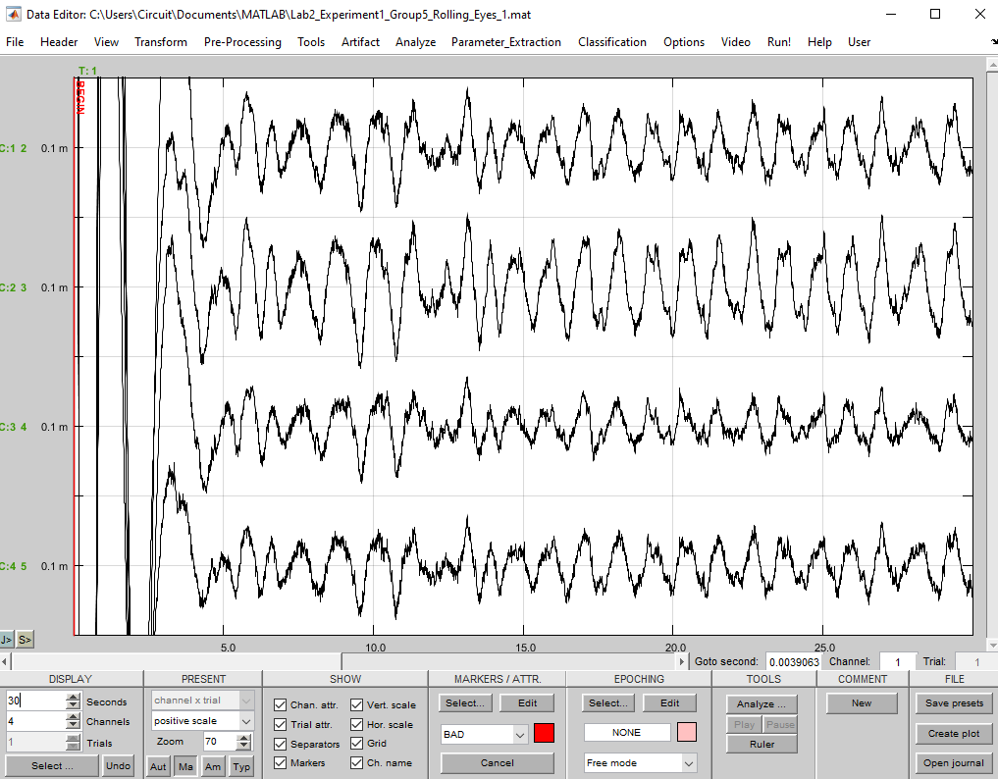

The waveform shows regular, repetitive spikes with a higher amplitude, indicating muscle artifacts caused by chewing. The pattern is more intense and chaotic compared to other movements.

* 1. Chewing

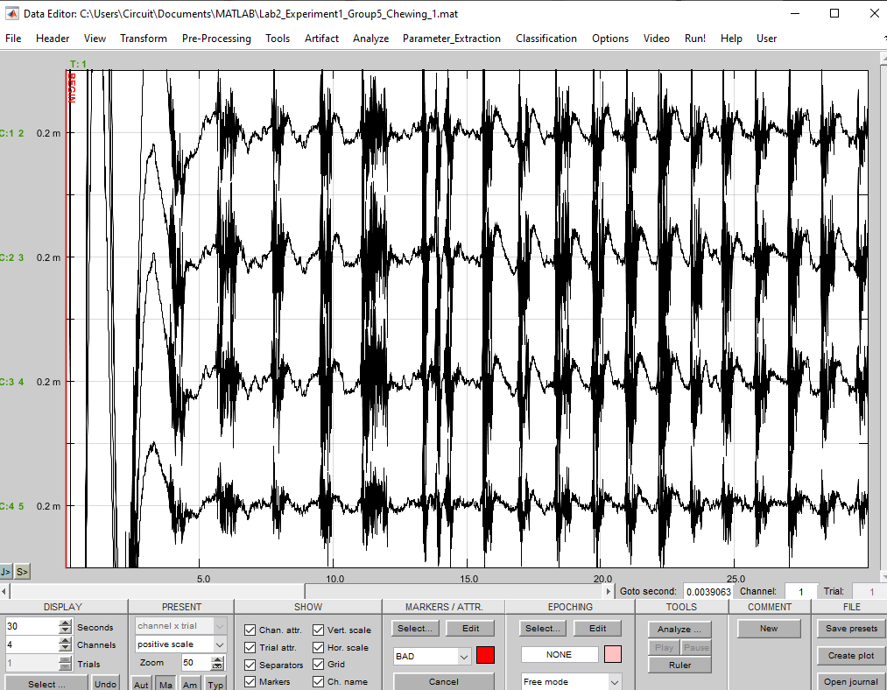

The signal exhibits irregular fluctuations, likely from neck muscle activity, with variable amplitude and frequency, less regular than the chewing artifact but more prominent than baseline EEG signals.

* 1. Neck Muscles

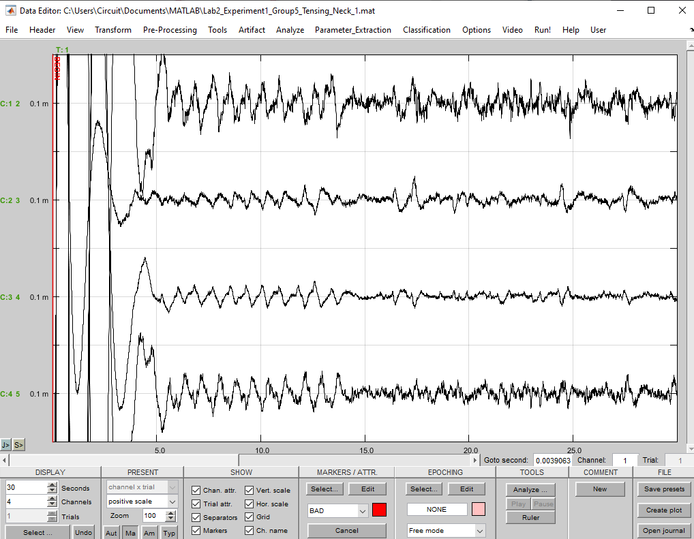

The waveform shows sharp, sudden spikes, characterized by brief bursts of high amplitude, indicating direct physical interference with the electrodes, creating large artifacts.

* 1. Touching Electrodes

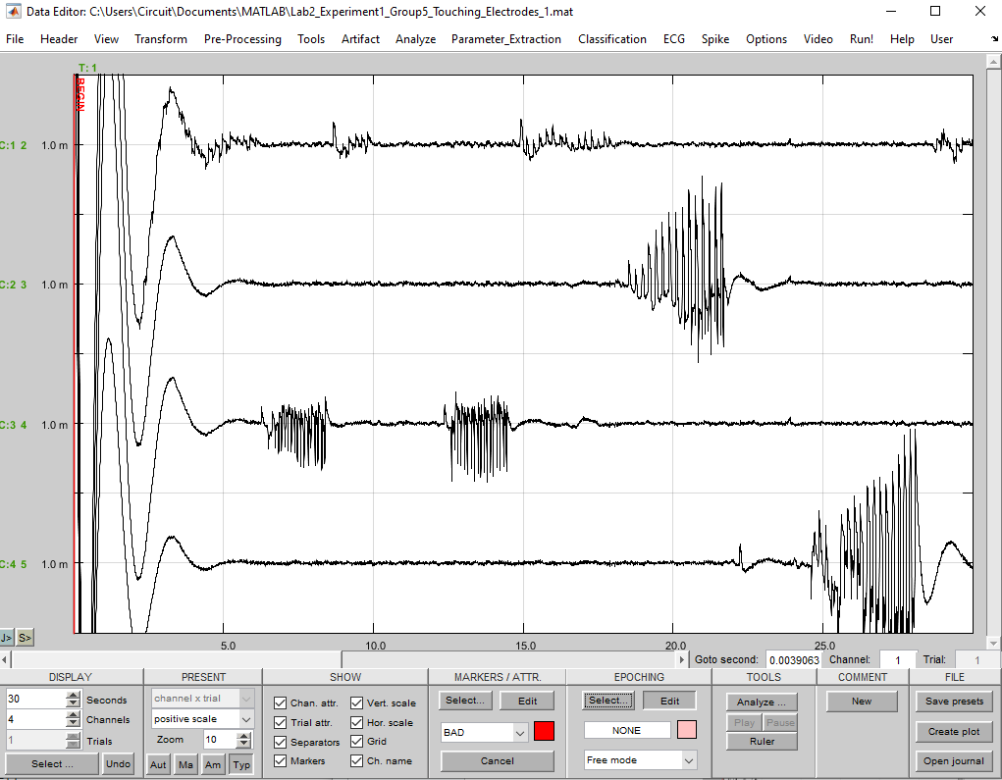

The waveform displays large, abrupt spikes followed by irregular oscillations, indicating strong artifacts caused by direct contact with the electrodes.

1. For each of the behavioral conditions (sitting silently, blinking, rolling eyes, chewing, tensing the neck, touching the electrodes), **find the frequency range where each artifact is present**. How does this frequency range compare to silent sitting?
   1. According to our recorded signal, the frequency range of eye blinks is 0.75-1 Hz, rolling eyes is about 1 Hz, chewing is about 10 Hz (we cannot really tell from that pic), tensing neck muscles is about 1.5 Hz and touching the electrodes is approximately 3.5-5 Hz. These behavioral conditions all generate much higher frequency than silent sitting.

Data Analysis

| Condition | Peak to Peak  AKA amplitude | Frequency Range |
| --- | --- | --- |
| 1 Sitting quietly | 49.3 uV | 0-40hz; peak at 0Hz and 18Hz    We should expect to see a frequency range of alpha waves between 8-13Hz. |
| 2 Blinking | 0.135 mV | 0-7Hz; peak at 0Hz    We should expect to see multiple spikes in the power spectrum especially in the 0-7 range. |
| 3 Rolling eyes | 0.145 mV | 0-5Hz; peak at 0Hz    The mechanical EMG movement of the eyes can distort the EEG signal making it difficult to interpret the underlying brain activity. |
| 4 Chewing | 0.403 mV | 0-70Hz; peak around 35 Hz and 65 Hz |
| 5 Tensing neck | 0.4225 mV | 0-5Hz; peak at 0Hz |
| 6 Touching Electrode | 1.312 mV | 0-35Hz; peaks at 5Hz, 10Hz, 15Hz |

**Experiment 2: Bipolar Derivation**

Comparative Analysis of Derivations

1. Create graphs that compare the bipolar derivations with the monopolar derivations when you produce EMG artifacts by blinking with the eyes and chewing. Which derivation suppresses the EOG (blinking) artifacts best?

Blinking Bipolar Chewing Bipolar

* 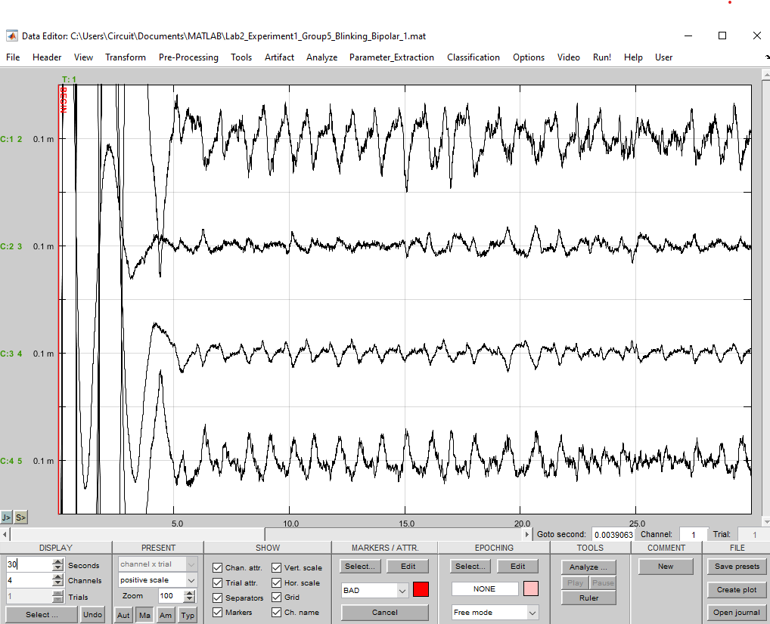 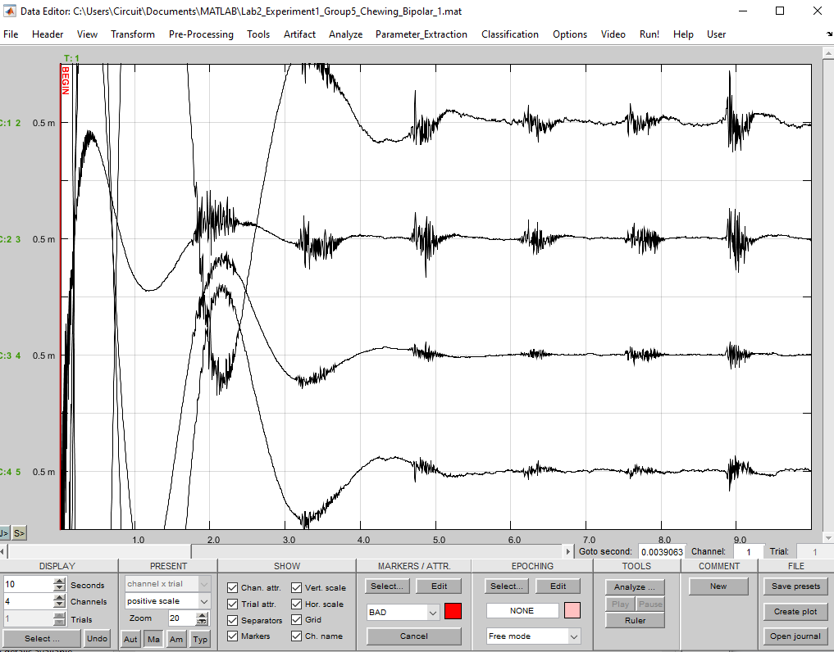
* Blinking monopolar Chewing monopolar

 

It appears that bipolar derivation tends to suppress blinking artifacts (EOG) more effectively. The signal in the blinking bipolar graph shows less prominent peaks corresponding to blinks, suggesting better suppression.

For blinking the bipolar configuration shows less artifact impact than the monopolar configuration. In the bipolar derivation the amplitude of the artifacts is lower and more localized.

1. Why?

* Bipolar derivation reduces noise by connecting two electrodes that are close to each other, allowing common noise to be canceled out by measuring the difference between the two adjacent electrodes. This approach helps capture a clearer signal from brain rhythms, as both electrodes detect similar signals, which can then be offset.

1. Which derivation suppresses the EMG (chewing) artifacts best?

* Bipolar derivation also suppresses the EMG artifacts better as the signal is more smooth and the spikes are easy to tell and distinguish. The monopolar instead shows very pronounced muscle artifacts including high amplitude fluctuations in all the channels.

1. Why?

* The common noise is reduced using bipolar while monopolar records activity at a single electrode against a distant reference.

After switching off the notch and bandpass filter and perform one bipolar derivation to compare with the monopolar derivations. The remaining channels should be monopolar for comparison.

1. Create a graph that compares the derivations.

Blinking No Filter Chewing No Filter

* 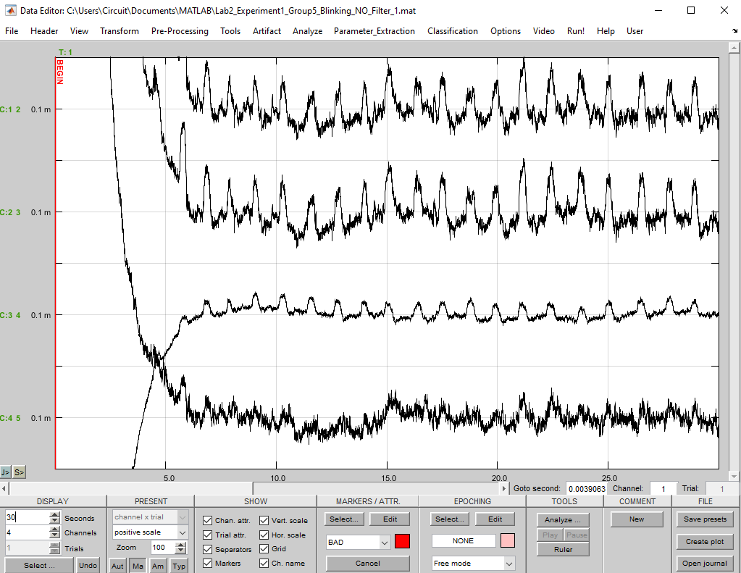 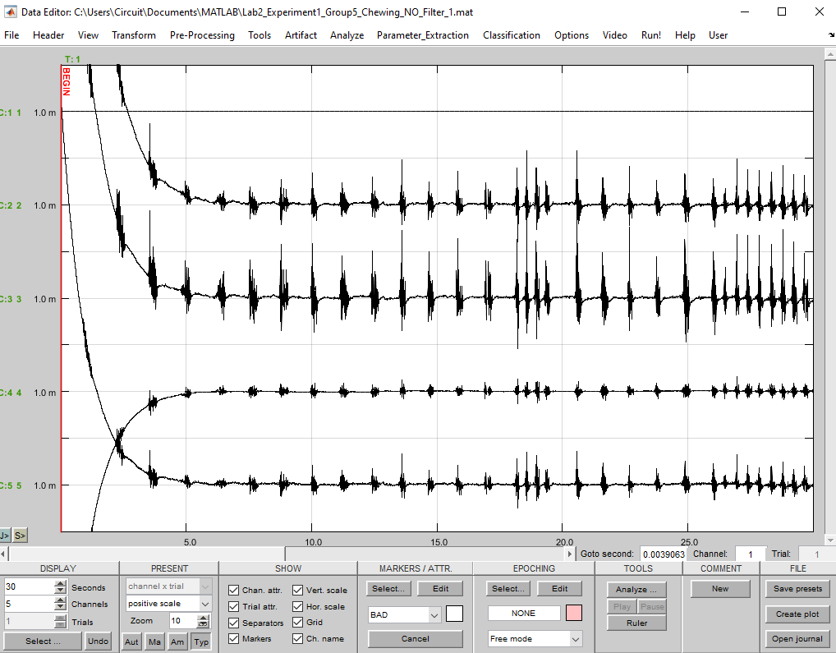

1. Does the bipolar recording help reduce the power line interference?

Original

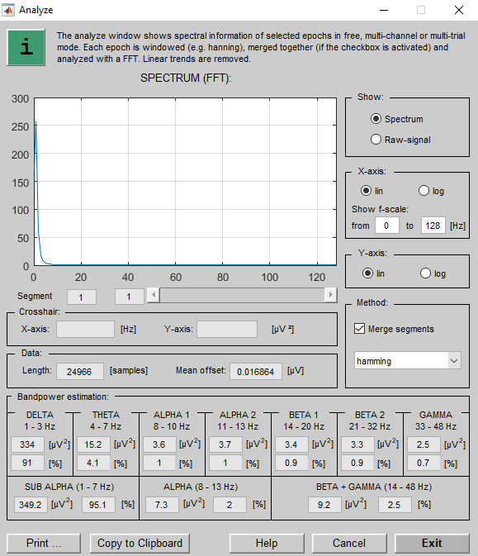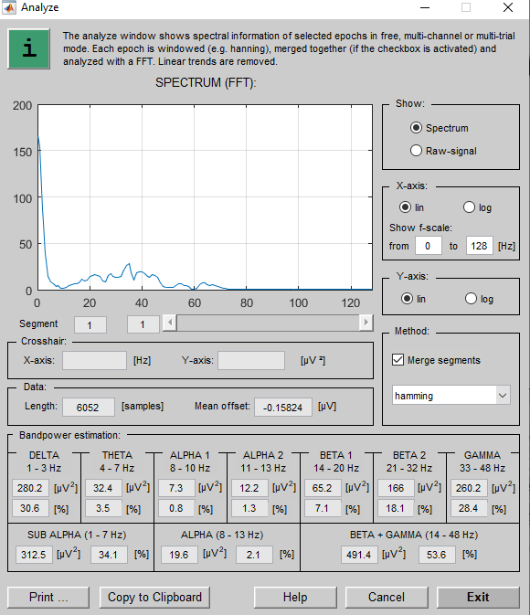

Blinking-Bipolar Chewing-Bipolar

* 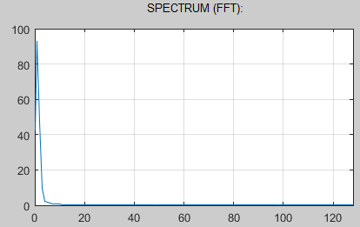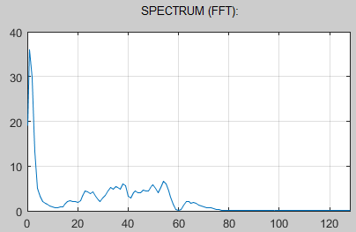
* As the FFT graph shows which frequencies are most prominent in the signal and we can see there is a reduction at around 50-60Hz, we can tell bipolar recording does help us to reduce the noise from 50-60 Hz, which therefore mainly comes from power lines.

1. How large is the reduction of the 50/60 Hz power line noise in dB?

Blinking Chewing

* 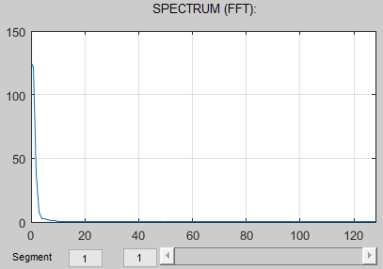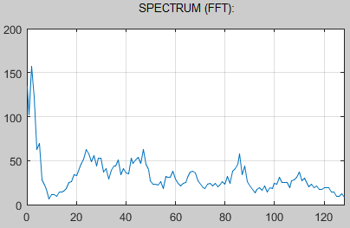
* For 55-60 Hz: around 30dB - 0dB = 30dB
* For 50-55 Hz: around 40dB - 30dB = 10dB